|  |
| --- |
| Technical Milestone 2 |
| Dylan StoneApplied Research Project 1November 24, 2016 |

My ultimate goal for my final project is to calculate the heat generation in a unit of power to see the true power generated by the Cansolair solar heating system. In order to calculate heat generation I will need to calculate heat differential and the amount of air heated, and I have measured and calculated heat differential in my first milestone. For this milestone I will be deciding on a way to calculate the amount of heated air, by taking the air flow and duct size into account.

I began by searching the Cansolair website, on their [FAQ](http://www.cansolair.com/faq/customers-faq) they claim the unit has a fan capable of a 47 litre per second flow rate, although it did not go into specifics about when or how often the fan would be running. I emailed James Thomson and he got a hold of Cansolair, where he found out the fan runs at a constant speed, and is only turned on when the temperature inside the system is sufficient to heat the inside space. There are check valves on the system that keep the air still in the system while it is heated, and the valves let air flow when the fan runs.

I need two things to calculate total air flow, the flow rate, and when air is flowing. I know flow rate is constant so I only need a one-time measurement that I can use to calculate air flow. The 47 LPS flow rate listed on the Cansolair website will be a good starting point, but the conditions at the school may be slightly different so I plan on temporarily using an air flow meter to get an accurate flow rate measurement. Until I can get a more accurate measurement I will use the 47LPS number for any calculations I make. The only other thing I need to know is when the fan is running, for this I plan on using an infrared sensor looking at the air flow valves to see when the valve is open which would mean the fan is running and air is flowing. If I know when the fan is running I can have the Raspberry Pi only calculate heat generation while air is flowing. If the fan is running the Raspberry Pi will take temperature differential measurements. In order to calculate heat generation it will average each instantaneous temperature differential while the fan is running, and it will use the single average temperature differential with air flow to calculate power generated for the cycle. I can calculate total power generated by the system by calculating:

Energy per second (KJ/s) = heat capacity (1 KJ/Kg OC) * mass ((Kg/m3)(m3/s)) * temperature differential (OC)

After simplifying constants like the heat capacity of air I find:

Energy = 1.125 * Flow rate in LPS * Temperature Differential

(W) = (1 KJ/Kg OC) * (Kg/m3) * (1000 * m3/s) * (OC)

This is the primary formula I will be using. For example; if the heater was making a 2 degree temperature differential for 1 minute at 47LPS it would be outputting 1.125 * 47 * 2 = 105.8 Watts for 1 minute so 105.8 Watt minutes. This translates to 1.7625 KWH which is a common unit for power so this would be a good translation to see a single number that shows total power generated. This will be the cheapest, most efficient way to measure power generation as it does not need a constant air flow measuring device, which could be very expensive, as the air flow is constant in this system.

Next I need to setup an infrared detector to check for an open or closed valve and add power calculation into my program. Once I know the kinds of things I will be attaching to my board I can begin designing a PCB for my third milestone. The following pages have pictures of the Cansolair intake inside the building.

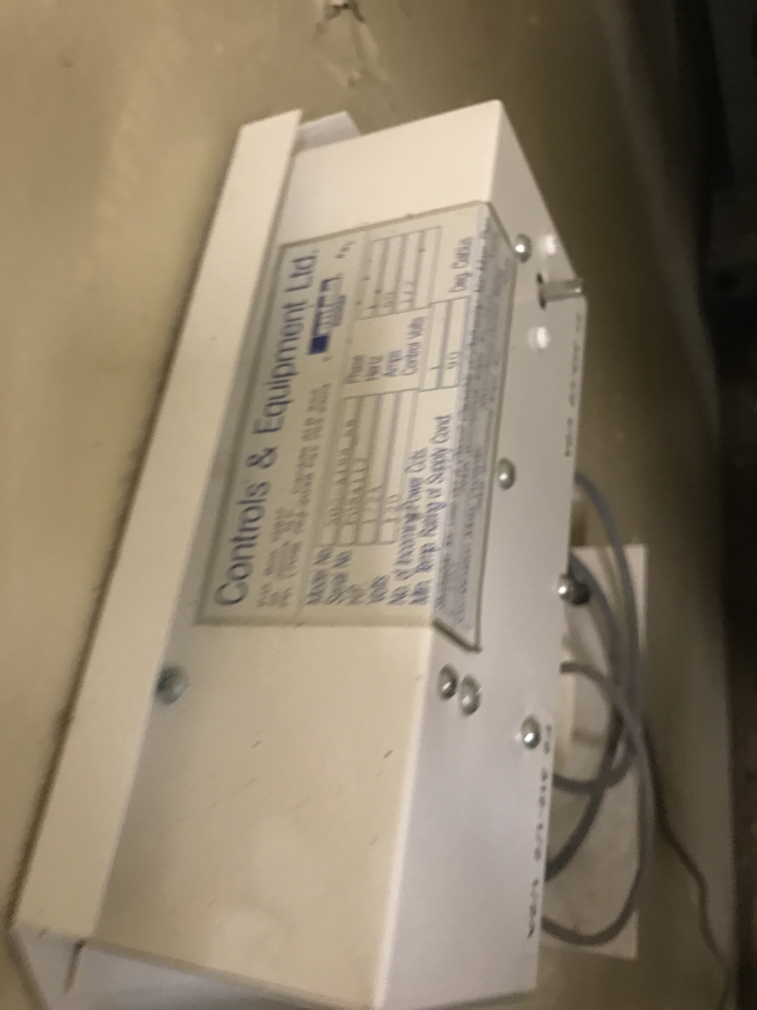

Figure 1

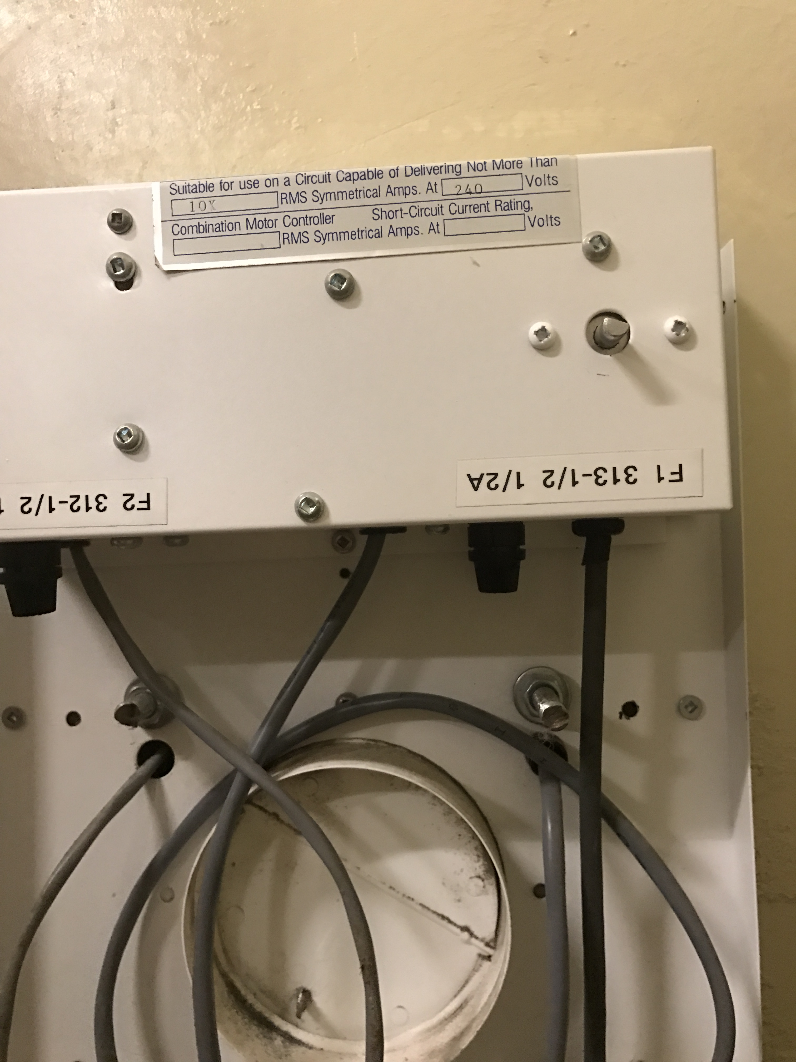

Figure 2

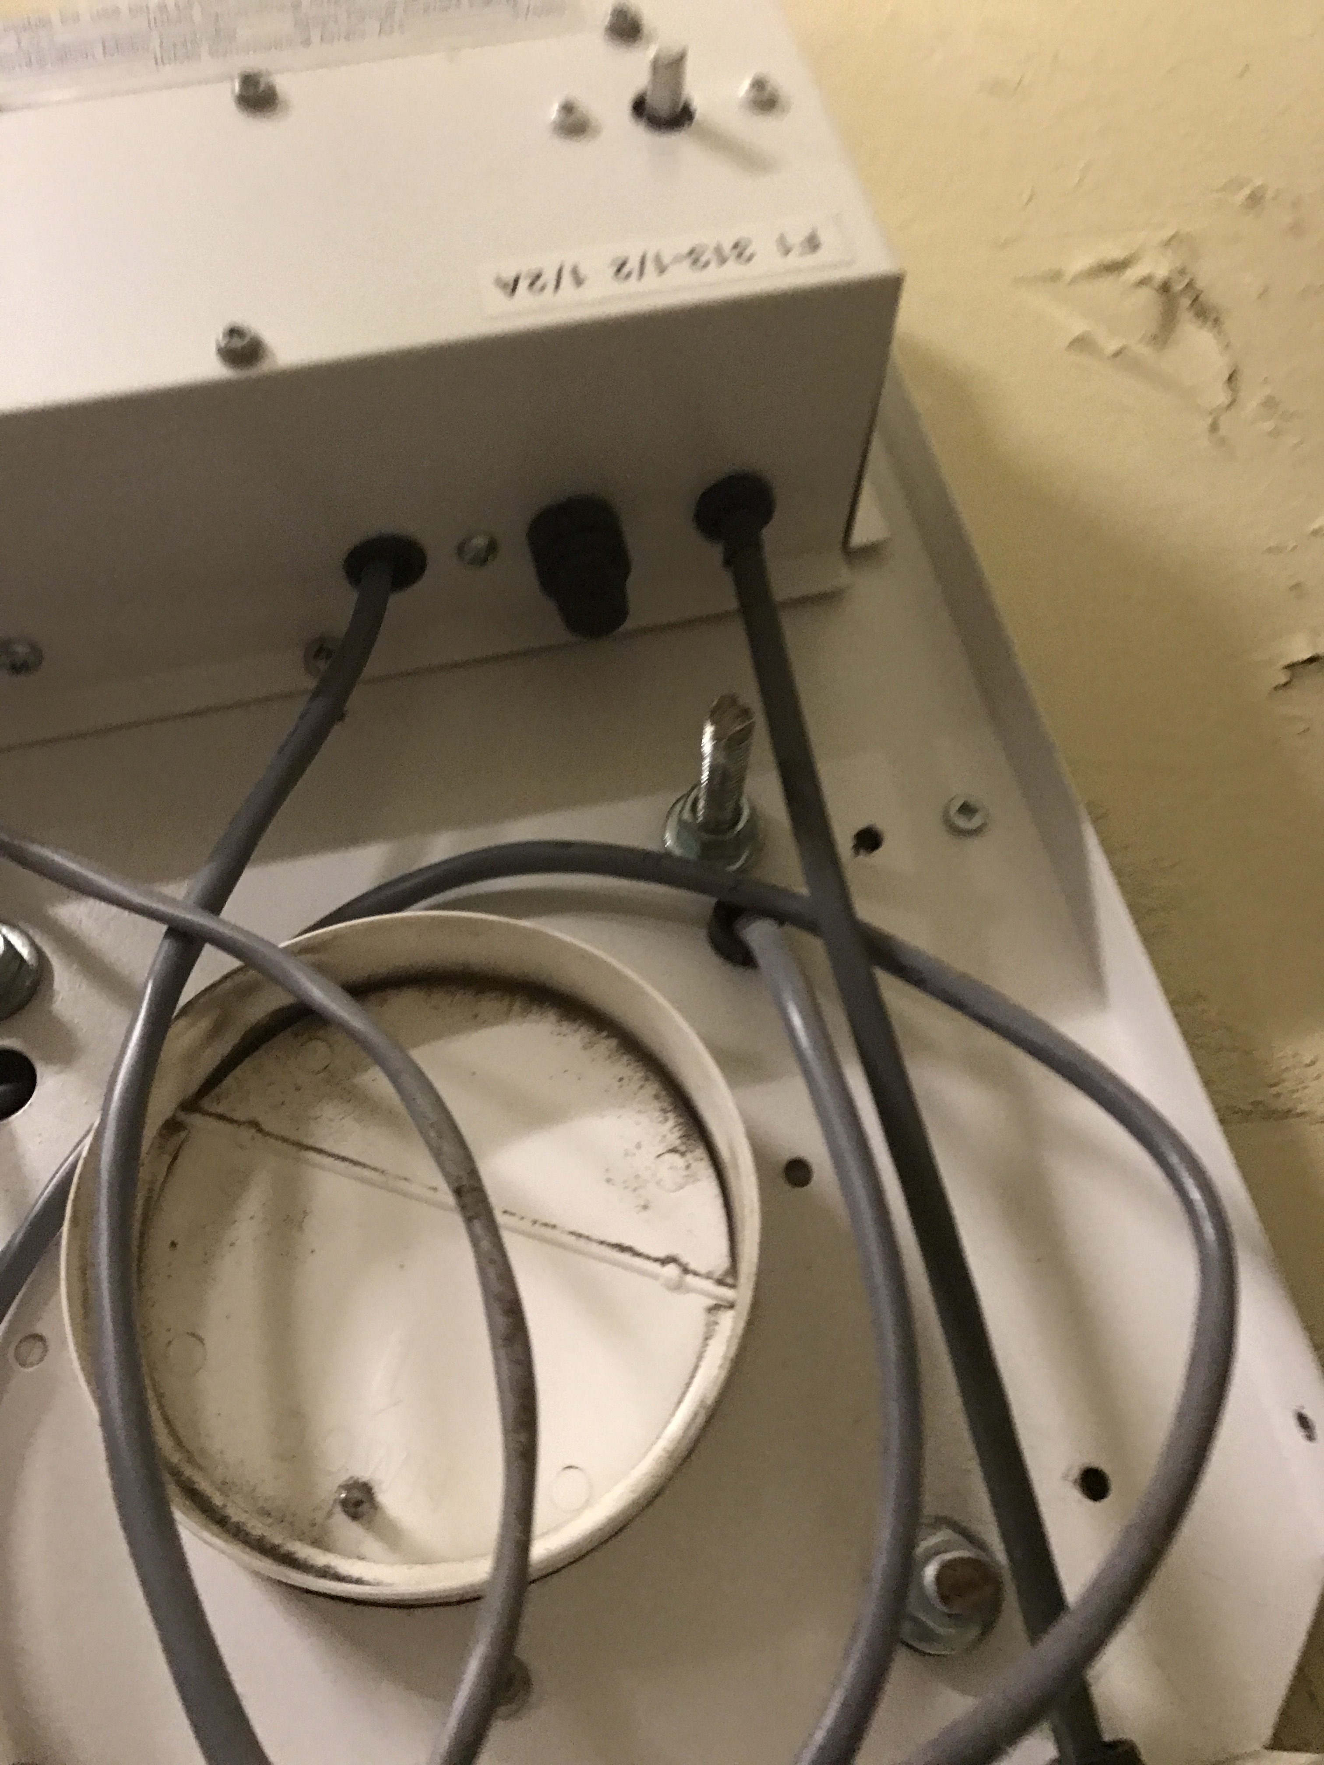

Figure 3

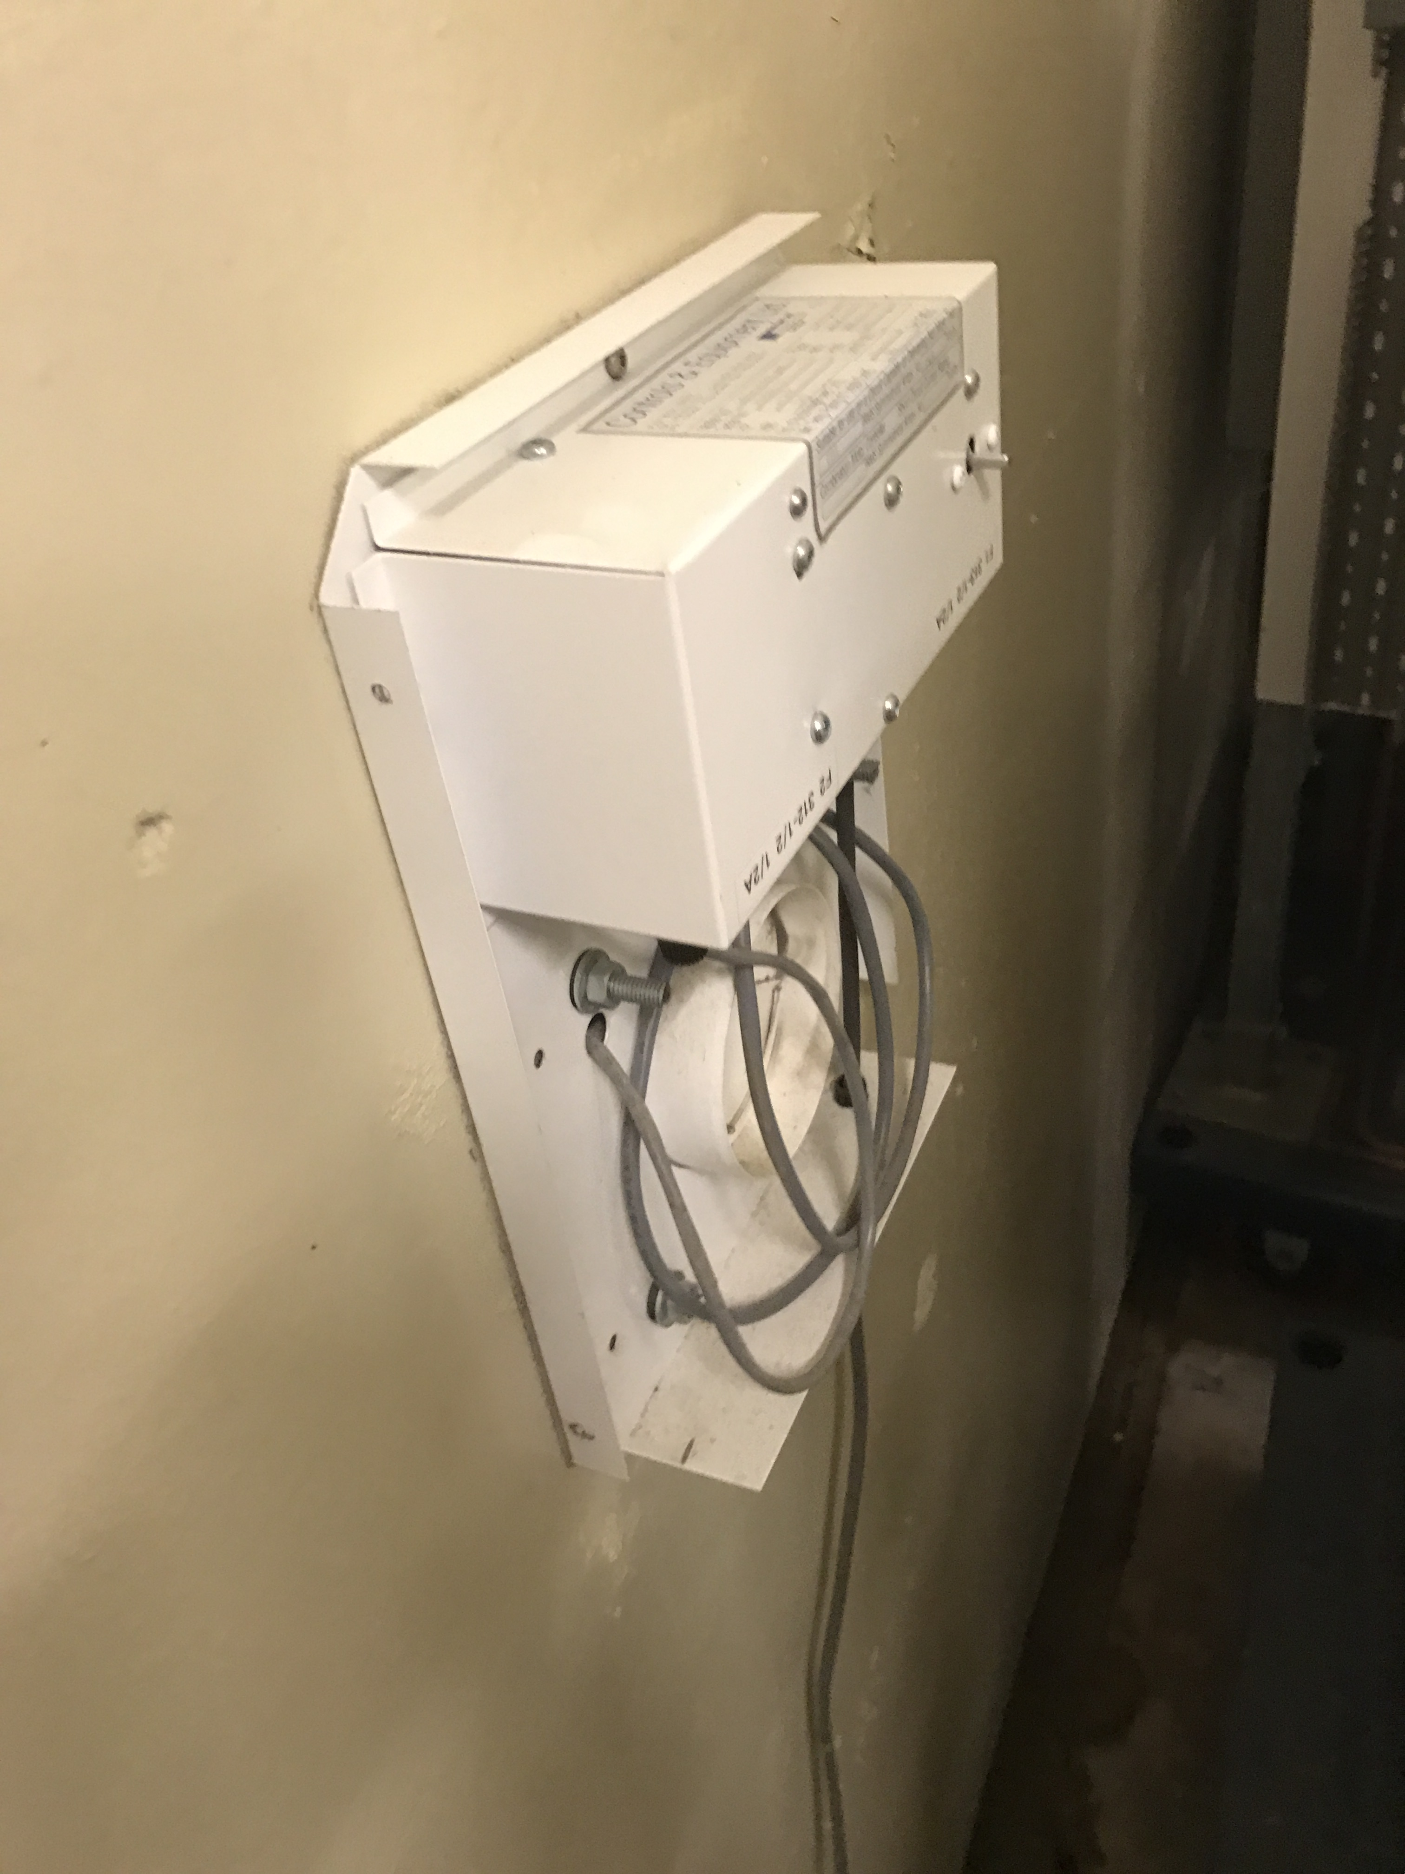

Figure 4

# References

*Cansolair FAQ*. (2016, 11 23). Retrieved from Cansolair: http://www.cansolair.com/faq/customers-faq/